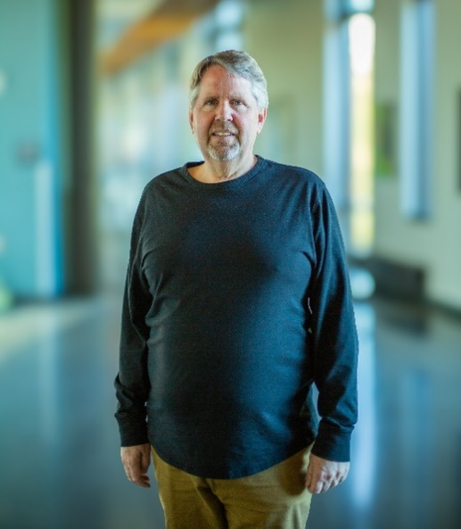

Steven Danver, Dean of Arts & Sciences Humanities by Chris Urquia 2024

